Name: _________________________________Country:_____________________________

Africa Project Rubric
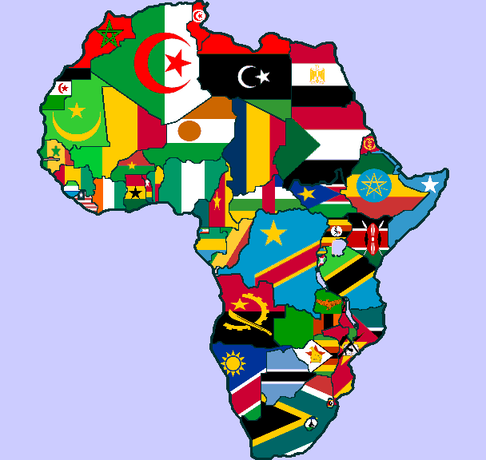
Africa Project Written Report Rubric:
Title Page
Typed ____/1
Three Graphics ____/3
Title____/1
Name and Class ____/1
Neatness ____/1
Fact Page
Typed ____/1
Fits on one page ____/2
Full facts ____/11
Flag
Accurate ____/1
Neat and Colorful ____/2
History/explanation ____/3
Map
Neat and Colorful ____/2
Bodies of water ____/2
Capital ____/1
Two major cities ____/1
Bordering countries ____/1
Physical features ____/2
Key and rose ____/2
Stamp
Includes a cultural symbol or historic event ____/1
Neat and Colorful ____/2
Paragraph (at least 4 sentences) ____/4
Written Report Total ______/45

Africa Project Presentation Report Rubric:
Information about cultural element or historical event ____/8
Use of technology was clear and organized ____/3
Clear Speech (Voice) ____/2
Eye Contact ____/2
Presentation Total ______/15

Africa Project Total ____/60

